**REPL and Modules Assignment**

**Assignment 1: Named Exports with Aliases**

Objective: Practice using named exports and aliases during import.

Question:

Create a module mathOperations.js that exports the following functions using named exports:

add(a, b)

subtract(a, b)

In main.js, import these functions using aliases (e.g., add as sum, subtract as diff) and log the results of sample calculations.

**mathOperation.js**

export function add(a, b) {

return a + b;

}

export function subtract(a, b) {

return a - b;

}

**main.js**

import { add as sum, subtract as diff } from './mathOperations.js';

console.log("Sum of 5 and 3 is:", sum(5, 3));

console.log("Difference of 10 and 4 is:", diff(10, 4));

**Output:**

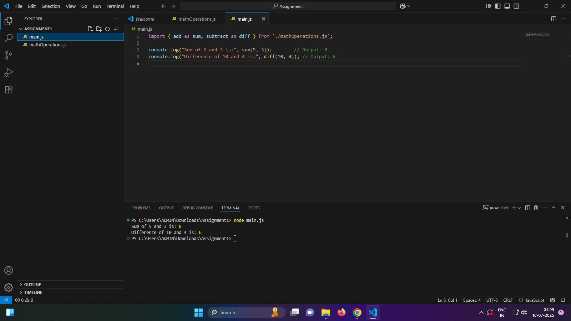

**Assignment 2: Dynamic Imports**

Objective: Understand how to load modules at runtime using import().

Question:

Create a module stringUtils.js that exports a function capitalize(word).

In main.js, use dynamic import to load stringUtils.js only when the user inputs a word. Display the capitalized word using the imported function.

**stringUtils.js**

export function capitalize(word) {

if (!word) return '';

return word.charAt(0).toUpperCase() + word.slice(1).toLowerCase();

}

**main.js**

import readline from 'readline';

const rl = readline.createInterface({

input: process.stdin,

output: process.stdout

});

rl.question('Enter a word: ', async (word) => {

if (word) {

try {

const stringUtils = await import('./stringUtils.js');

const capitalized = stringUtils.capitalize(word);

console.log(`Capitalized: ${capitalized}`);

} catch (err) {

console.error('Error importing module:', err);

}

} else {

console.log('No word entered.');

}

rl.close();

});

**package.json**

{

"type": "module"

}

**Output:**

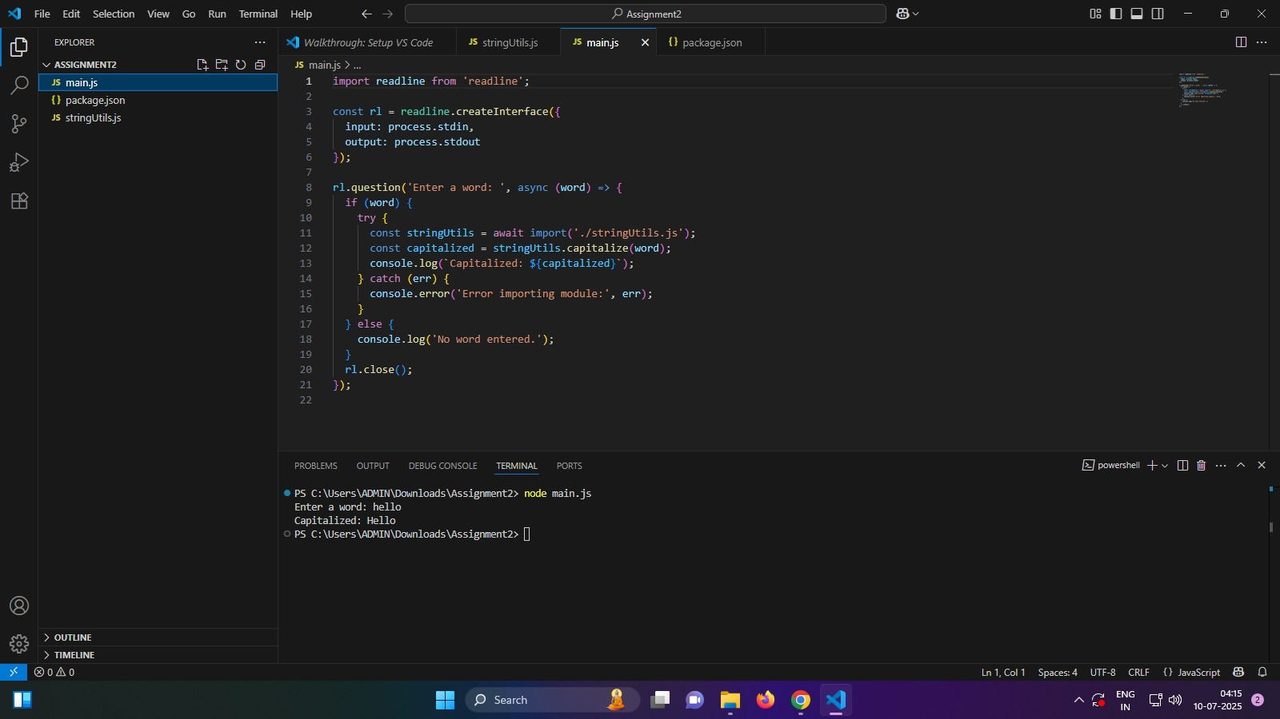

**Assignment 3: Combining Default and Named Exports**

Objective: Learn how to combine default and named exports in the same module.

Question:

Create a module user.js that:

Exports a default class User with properties like name and a method getInfo().

Also exports a named function validateEmail(email).

In main.js, import the class and the function, create a User instance, and validate a sample email address using the function.

**user.js**

export default class User {

  constructor(name, email) {

    this.name = name;

    this.email = email;

  }

  getInfo() {

    return `Name: ${this.name}, Email: ${this.email}`;

  }

}

export function validateEmail(email) {

  const emailRegex = /^[^\s@]+@[^\s@]+\.[^\s@]+$/;

  return emailRegex.test(email);

}

**main.js**

import User, { validateEmail } from './user.js';

const newUser = new User('Keerthi', 'keerthi31ms@gmail.com');

console.log(newUser.getInfo());

const sampleEmail = 'keerthi31ms@gmail.com';

console.log(`Is "${sampleEmail}" a valid email?`, validateEmail(sampleEmail));

**package.json**

{

    "type": "module"

}

**Output:**

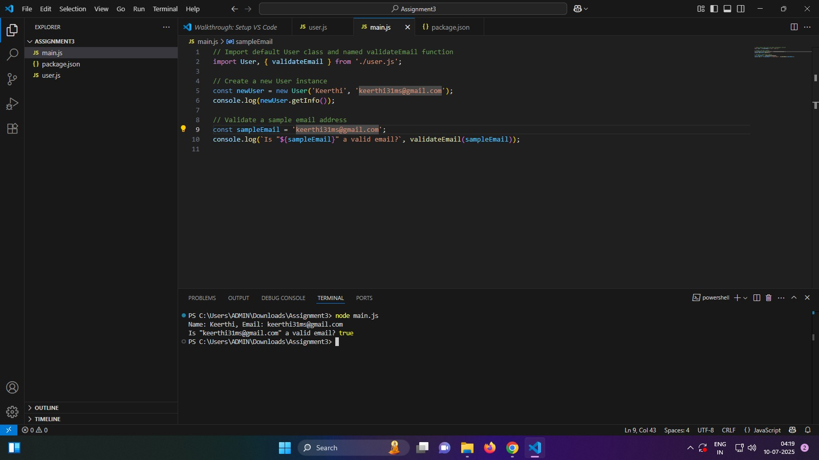

**REPL**

Write a JavaScript program that:

Takes a predefined array of integers.

Uses a loop to iterate through the array.

Checks each number to see if it is even.

Calculates the sum of all even numbers in the array.

Prints the final sum.

**main.js**

let numbers = [5, 8, 12, 3, 7, 10, 4];

let sum = 0;

for (let i = 0; i < numbers.length; i++) {

  if (numbers[i] % 2 === 0) {

    sum += numbers[i];

  }

}

console.log("Sum of even numbers:", sum);

**Output:**

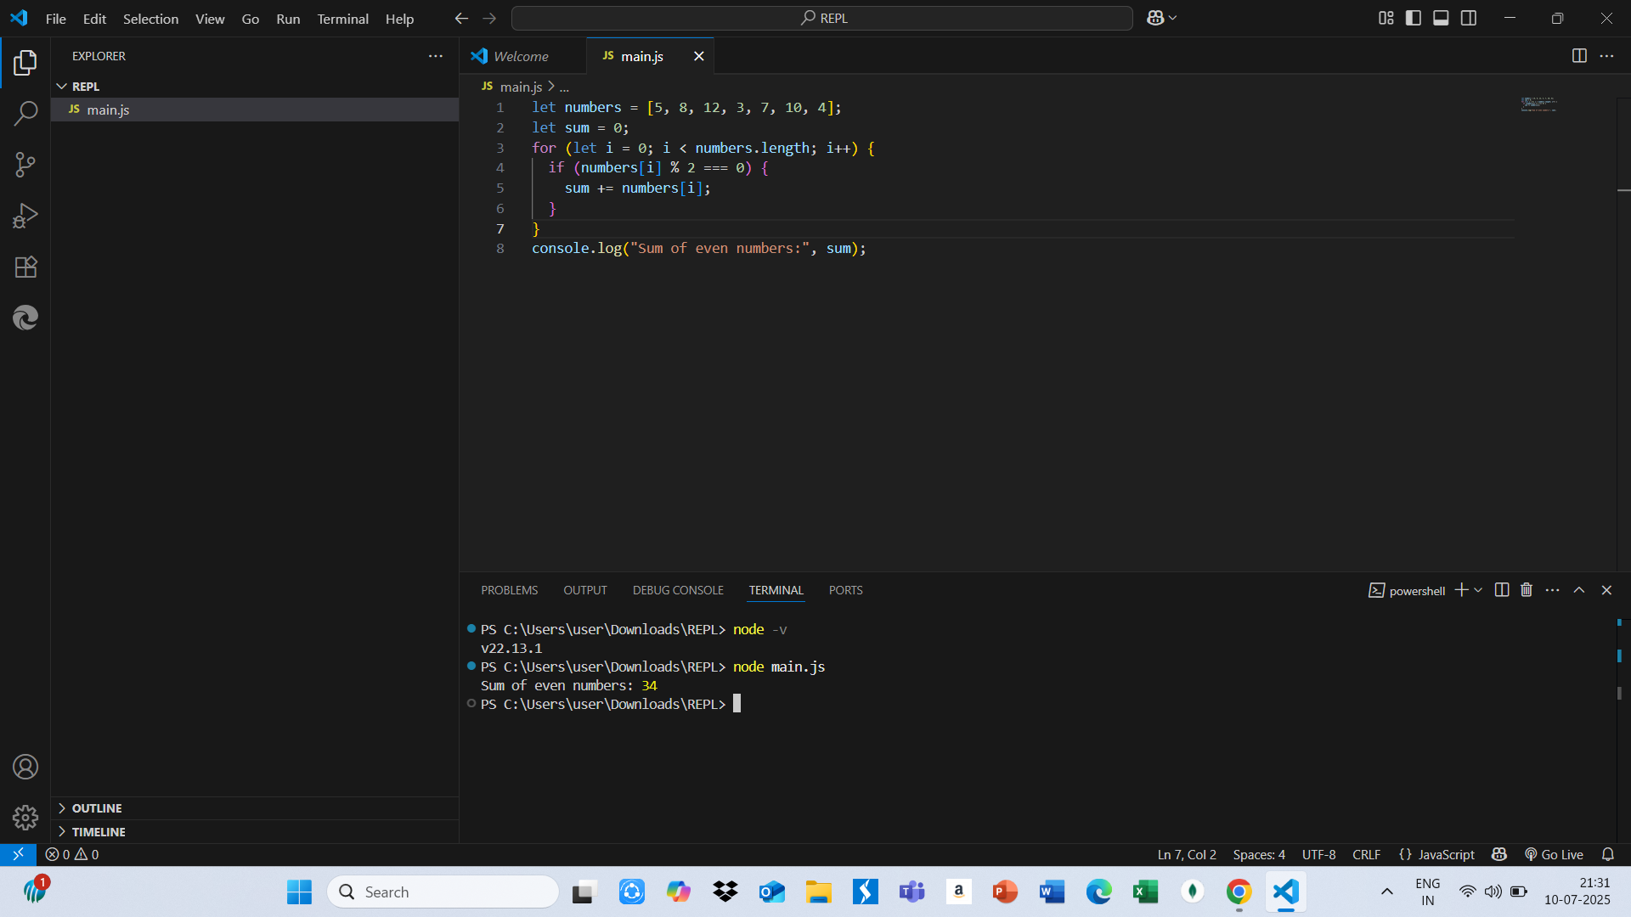

**Explanation:**

REPL stands for Read-Eval-Print Loop, and it is an interactive programming environment used in languages like Python, JavaScript (Node.js), Ruby, and Scala. It works in a continuous cycle where the system **reads** the user’s input (usually a single line of code), **evaluates** or executes that code using the language's interpreter, **prints** the result of the evaluation (such as a value or error), and then **loops** back to wait for the next input. This process allows developers to interact with the programming language in real time without needing to write, save, and run full programs. REPL is especially useful for beginners learning how syntax, loops, conditions, and functions work because it provides instant feedback for each line of code entered. For example, in Python, typing >>> x = 5 and then >>> x * 2 immediately returns 10. In JavaScript’s Node.js REPL, entering > let a = 10; followed by > a + 5 returns 15. This instant-response environment makes REPL a powerful tool not just for learning but also for debugging, testing small pieces of logic, experimenting with functions, and rapidly prototyping new ideas. Common REPL environments include python or ipython for Python, node for JavaScript, and irb for Ruby. Overall, REPL is a lightweight, efficient, and beginner-friendly way to work with code interactively, enhancing both learning and productivity.